SIT123: Data Capture Technologies

# Sensing Soil Moisture Activity Sheet

## Hardware Required

* Arduino Board
* USB cable
* DFrobot Soil Moisture Sensor (<https://tronixlabs.com.au/sensors/moisture/dfrobot-soil-moisture-sensor-arduino-compatible-immersion-gold-australia/> )
* Male to Male Dupont Jumper Wires

## Pre-requisites: You must do the following before this task

**Read this sheet from top to bottom**

## Steps

1. Find the DFrobot Soil Moisture Sensor from the sensor kit and attach the provided wires to the sensor. This sensor comes with 3x jumper cables.
2. Connect the DFrobot Soil Moisture Sensor to the Arduino board using the images & steps a, b and c included below for guidance.

* Analog output(Blue wire)
* GND(Black wire)
* Power(Red wire)

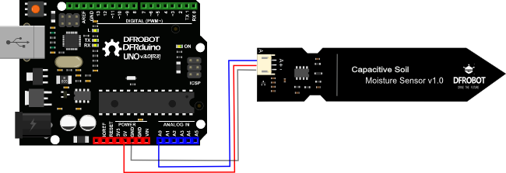

* 1. Pick a red male-male jumper wire and attach one end to the red wire (female) on the sensor. Plug the other end into the Arduino board’s 5V power pin.
  2. Pick a blue male-male jumper wire and attach one end to the blue wire (female) on the sensor. Plug the other end of the male-male wire into the Arduino board’s Analog data pin 0 (A0).
  3. Pick a black male-male jumper wire and attach one end to the black wire (female) on the sensor. Plug the other end of the male-male wire into the Arduino board’s GND pin.

1. Connect your Arduino board to your computer using the USB cable.
2. Download the provided code at https://github.com/FeifeiDeakin/DFRobotSoilMoisture. If you download it in .zip format, you must extract it to a location on your computer after you download it.
3. Open your Arduino IDE.
4. Go to the Arduino IDE. Select “File -> Open” and it will open a dialog box.
5. Select the DFRobotSoilMoisture.ino file inside the DFRobotSoilMoisture folder & click Open.
6. In your Arduino IDE, click on the ‘Verify’ button. This will check for errors and compile your code.
7. Now click the upload icon to upload the code to the Arduino board. If you get an error, check to be sure you’ve selected the correct device and port.
8. Open the Serial Monitor in the Arduino IDE by selecting Tools->Serial Monitor, or by clicking on the Serial Monitor icon.
9. Expose the sensor to different moisture levels and see what values are printed on the Serial Monitor!

(Hint: you don’t need to stick the sensor into a soil mix to test it! An easy way is to put some wet tissue in a cup and stick the sensor into the wet tissue. Be careful when you test the Arduino board & sensors with water! Make sure you don’t spill any, and wipe any remaining water from the sensor after you finish the experiment)

## References

<https://www.dfrobot.com/wiki/index.php/Moisture_Sensor_(SKU:SEN0114)>

<https://www.dfrobot.com/wiki/index.php/Capacitive_Soil_Moisture_Sensor_SKU:SEN0193>